## Problem Statement

Deploy a local k8s cluster (using minikube, k3s, or anything else) and deploy the DVWA application. Showcase/demo 3 attack surfaces as mentioned in its documentation.

### Expected output:

1. Sample k8s setup

2. Demo/Execution of the attack vectors.

If you have any questions, please feel free to reply.

Looking forward to hearing from you. Keep safe.

## Steps to reproduce:

## Procedure with Minikube

* Start the minikube to create cluster
* In this case since it’s a single cluster it automatically saves it as default one that’s been created by minikube
* Install minikube using chocolatey

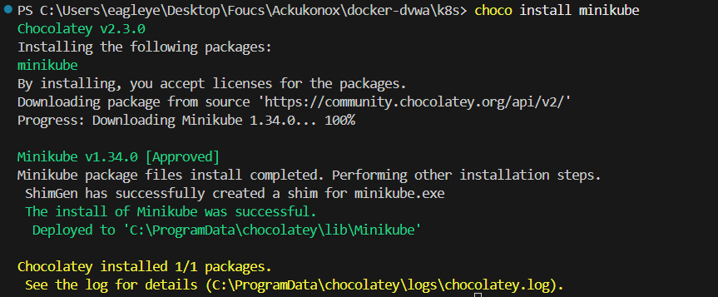

* Now that minikube installed created now create a cluster

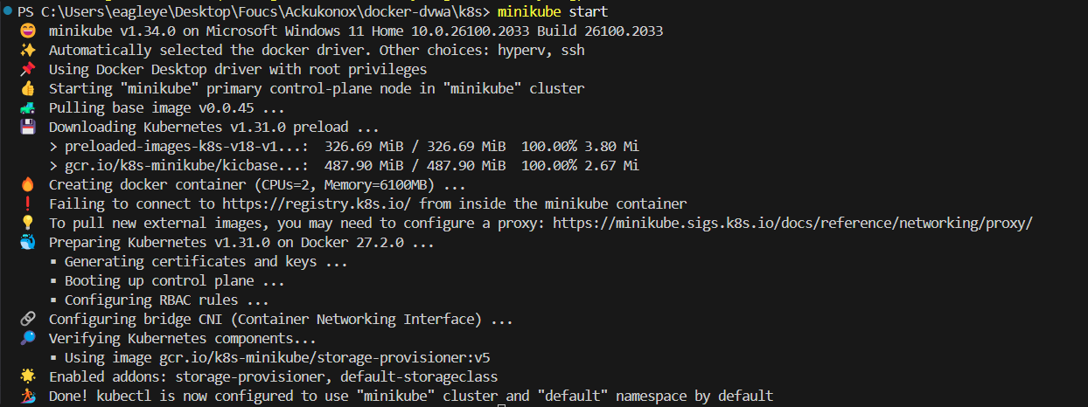

* Add addons as mentioned in docs

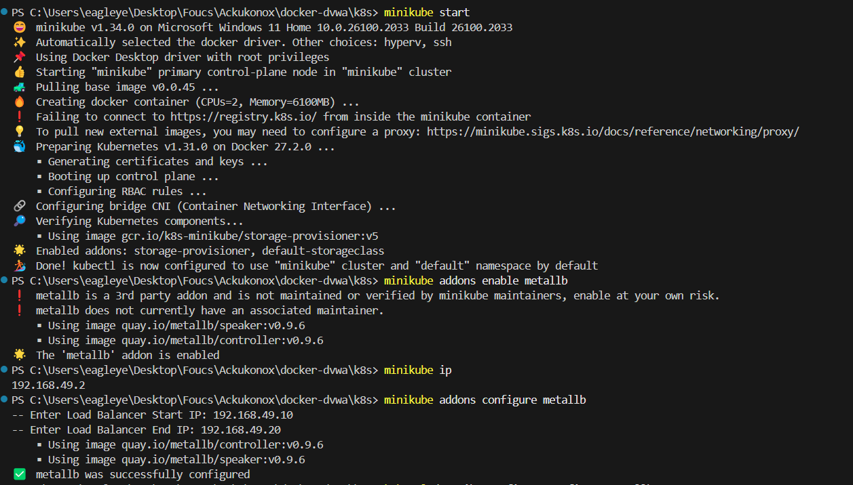

* Normally apply those k8’s files

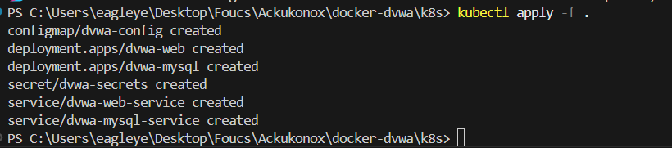

* Now that’s it’s been created let’s cross check pods if they are deployed or not

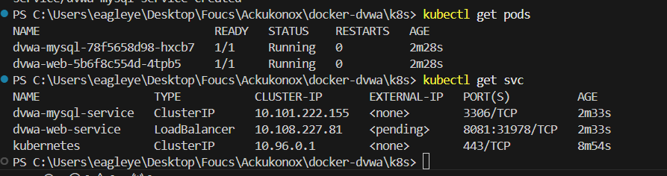

* Well, let’s check browser
* We can do port forwarding by using minikube or kubectl port forward or minikube tunnel

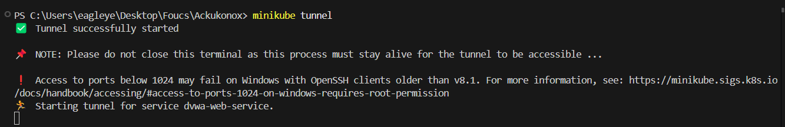

* Now go back to system and open local host:8081
* Scroll down and click on create

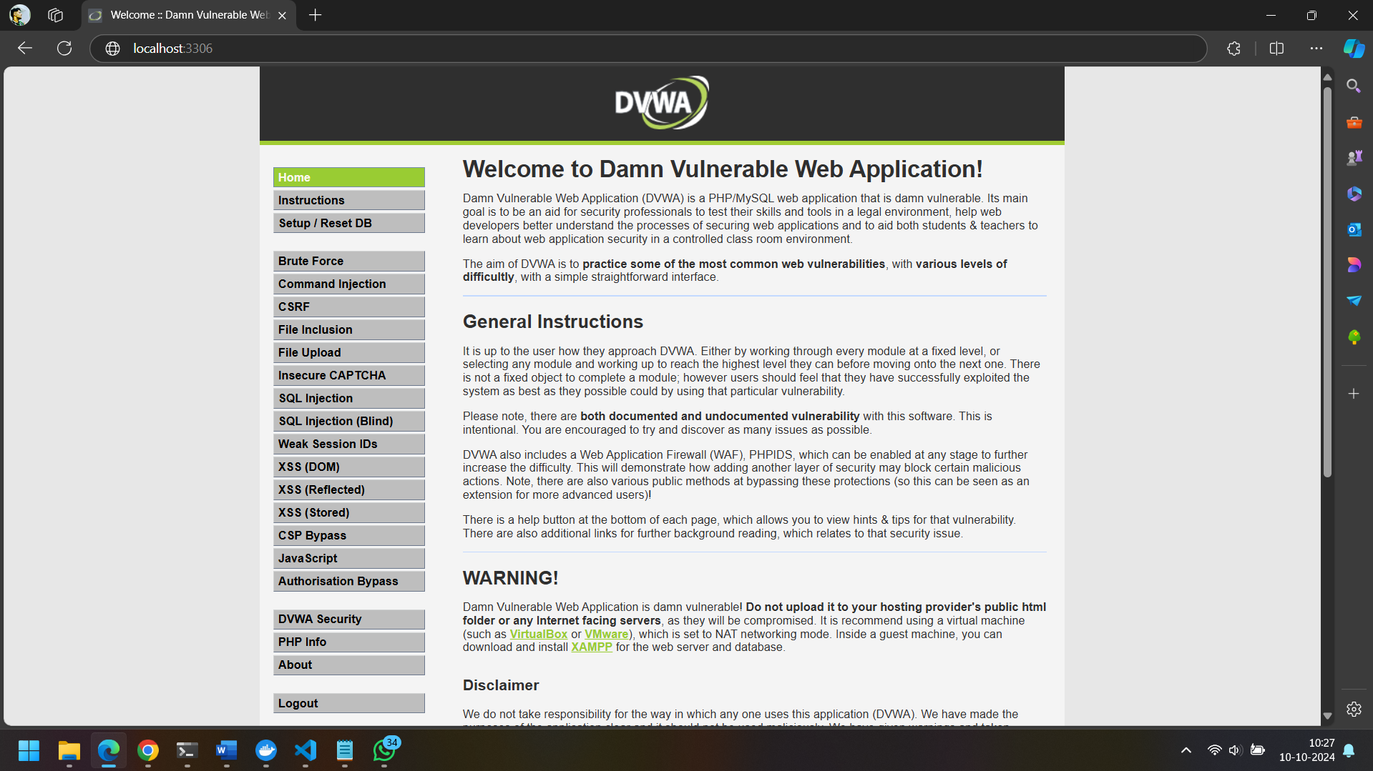

* Go to SQL injection Panel
* And fill user ID with ' OR '1'='1 and click on submit and you would see the data

* Navigate to Cross-Site Scripting
* And fill your name with Gani<script>alert(‘hello from saiganesh’)</alert>angadi

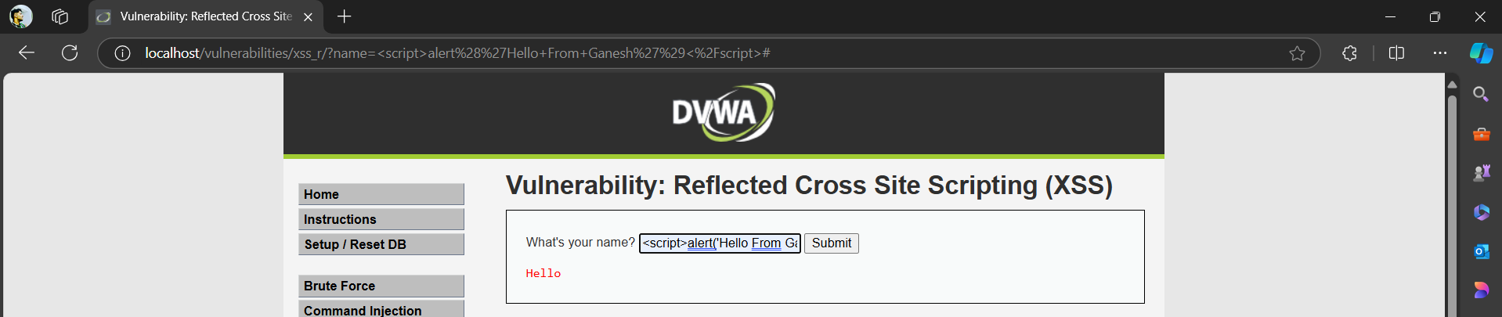

* Navigate to file Inclusion
* And type ;ls -al

* Capturing Flags

Flag 1:

Flag 2:

Converting into base 64

Ans: I do not like the room must have a leak.